Cyclic Redundancy Check (CRC) - Part 2

The divisor is common for both sender and receiver.

Receiver side

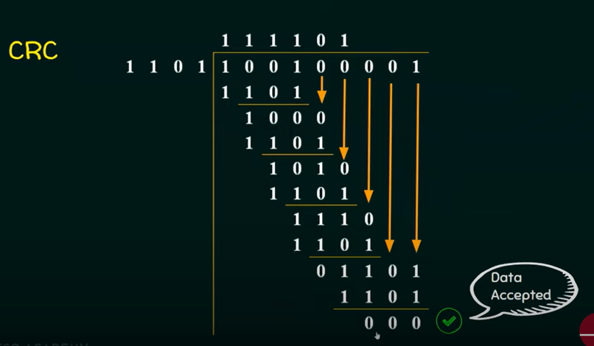

Homework

